## 

# **Executive Summary**

The report presents an extensive analysis of global population and urbanization growth trends and sustainability to seek fast-growing countries for rapid expansion by a multinational company. Two used real-world datasets are World Population Data (1960-2023) and Global Urbanization and Climate Metrics (1960-2023) in World Bank source. Key features in the datasets such as population, urbanization rate, GDP environmental sustainability are explored and measured by using metrics such as Compound Annual Growth Rate and Average Annual Calculations. While Average Annual Value simply reflects the average value across multiple years, Compound Annual Growth Rate describes long-term and consistent growth trends over time. The team adopted both metrics to make a comprehensive analysis of countries with good indicators and rapid growth of these indicators.

The objective is to identify countries experiencing rapid population growth, high urbanization growth rates, ensuring economic development and environmental sustainability. These countries are identified as emerging markets providing potentials for expansion. Key insights form the analysis such as:

* Population growth: Countries in Middle-East & North Africa such as Qatar, UAE, Kuwait, Jordan, Bahrain, Saudi Arabia and Sub-Saharan Africa such as Kenya, Gambia, Angola show the most rapid and consistent growth rates over the years.
* Urbanization trends: Countries such as Botswana, Bhutan, Angola, Bangladesh exhibit significant growth rates of urbanization percentages from 1960 to 2023.
* Environmental sustainability and opportunities: Some high and rapid-growth countries generate high CO2 emissions and energy consumption, but they also show their attempt to access renewable energy to gain sustainable development.
* Potential and fast-growing markets are countries having high GDP and consistent population and economic growth, rapid urbanization growth. These countries are low and middle-income countries with transitioning from low to lower-middle income or from lower-middle to upper-middle income level, which presents expanding purchasing demand and power. They bring potential markets with long-term sustainable development.

Table of Contents

Executive Summary 1

Introduction 4

1. Identify fast-growing markets 5

*1.1.* *Analysis using average annual values* 5

*1.1.1.* *K-means clustering analysis* 5

*1.1.2.* *Decision tree performance* 6

*1.2.* *Analysis using Compound Annual Growth Rate* 10

*1.2.1.* *Population growth analysis and insights* 11

*1.2.2.* *Urbanization growth analysis and insights* 12

*1.2.3.* *GDP vs urbanization growth based on income groups analysis and insights* 13

*1.3.* *Analysis’s results* 14

2. Overlay analysis 14

*2.1.* *A comparative analysis of global urbanization and population trends* 14

*2.2.* *Top Candidates for Expansion* 15

*2.3.* *Emerging Urban Growth Markets* 16

*2.4.* *Analysis’s results* 16

3. Assessment on Sustainability 17

*3.1.* *Things to consider* 17

*3.2.* *Cluster analysis* 17

*3.3.* *Cluster insights* 18

*3.3.1.* *Insight 1* 18

*3.3.2.* *Insight 2* 18

*3.4.* *Sustainability analysis’s results* 18

4. Recommendations 21

Conclusion 22

**Table of Figures**

Figure 1: k-Means Clustering Results based on Average Population, GDP and Urbanization Percentage 5

Figure 2: Decision tree classifier results 6

Figure 3: Decision tree visualization 7

Figure 4: Top 10 countries in cluster 0 7

Figure 5: Top 10 countries in Cluster 1 8

Figure 6: Top 10 countries in Cluster 2 8

Figure 7: Income groups in Cluster 1 8

Figure 8: Regions in Cluster 1 9

Figure 9: Distribution of total population, GDP and urbanization by regions in Cluster 1 9

Figure 10: Countries with top CAGR in Population 11

Figure 11: Countries with top CAGR in Urbanization 12

Figure 12: CAGR of GDP and Urbanization by Income groups 13

Figure 13: Distribution of countries based on Average Population and Urbanization percentage 14

Figure 14: k-Means clustering results based on CO2 emissions and energy consumption 17

Figure 15: CO2 emission levels of suggested countries 19

# **Introduction**

In this highly competitive marketplace requiring globalization, it is essential for the company to expand to emerging markets ensuring strong and rapid growth. This report analyses demographic, economic and sustainability features across countries and regions in the world to understand potential expansion opportunities for the company. The two datasets from World Bank which are World Population Data (1960-2023) and Global Urbanization and Climate Metrics (1960-2023) expose the key features including population records, urbanization rates, GDP values, income groups and environmental indicators. In the report, the team identify fast-growing countries with the best combination of three indicators which are population, urbanization and GDP growth with favorable income classifications. Then, the team perform overlay analysis to find out countries not only growing in population but also becoming urbanized over the time. After that, the team assess the sustainability of these potential and growing markets based on energy consumption and C02 emissions. Through all analysis, the team highlights specific countries by regions and propose recommendations. The output of the report is definitely useful for the decision-making process to launch the business into new markets.

# **Identify fast-growing markets**

Aiming to identify countries that not only exhibit high values in key indicators such as total population, GDP, urbanization percentage, but also demonstrate a rapid growth in these metrics over the years, the analysis utilizes both average annual values and Compound Annual Growth Rate calculations. Each approach is presented as below.

## ***Analysis using average annual values***

To start the analysis, the writer adopted average formula to calculate each country’s average values of total population and urbanization rates from 1960 to 2023 and GDP in the years from 2000 to 2023. This metric will help to extract countries with large population, high urbanization rates and elevated GDP. These data are then analyzed by K-means method on Weka to segment countries and find out the best group of potential markets.

### *K-means clustering analysis*

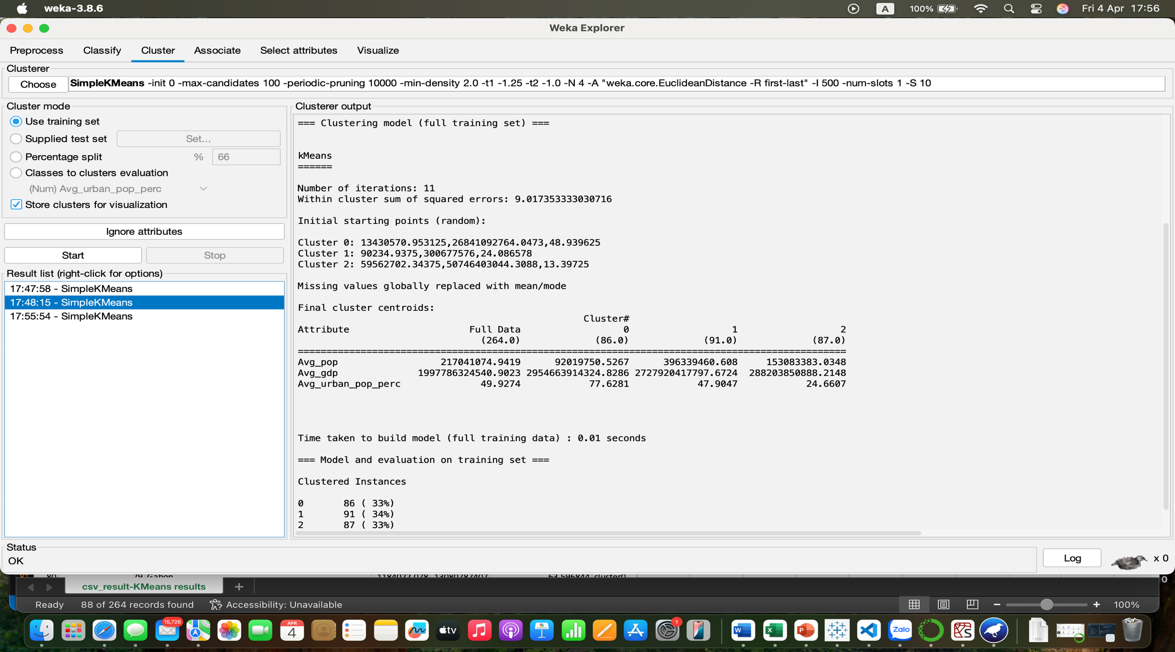

Figure 1: k-Means Clustering Results based on Average Population, GDP and Urbanization Percentage

Summary of clusters:

|  |  |  |  |
| --- | --- | --- | --- |
| **Attributes** | **Cluster 0** | **Cluster 1** | **Cluster 2** |
| **Avg_pop** | Small | Large | Moderate |
| **Avg_GDP** | High | High | Low |
| **Avg_urban_pop_perc** | High | Moderate | Low |

Figure 1 presents a summary of 3 clusters with key variables such as average population value, average GDP value and average urban population percentage. It can be seen that countries belonging to cluster 0 are highly urbanized and developed with only 92 million people but high GDP (2.95 trillion) and great urban population rate (77.7%). They are the most urbanized and wealthiest countries with strong economies. Cluster 1 shows a group of countries with large population (396 million) and moderate urbanization (47.9%). This cluster has a similar GDP (2.72 trillion) to cluster 0 despite much higher population, which means the countries in this group have lower per capita income. They are emerging economies. The other countries in cluster 2 are the least urbanized (24.6%) with the lowest GDP (288 million). They are developing countries with significant rural population.

### *Decision tree performance*

After segmenting countries into 3 clusters displayed by different features that are population, GDP and urbanization, the writer utilizes decision tree – classification model on Weka to find out what feature is the most important in each cluster. From that, the writer can rank countries in each cluster based on this identified feature and extract top countries from the list on Excel.

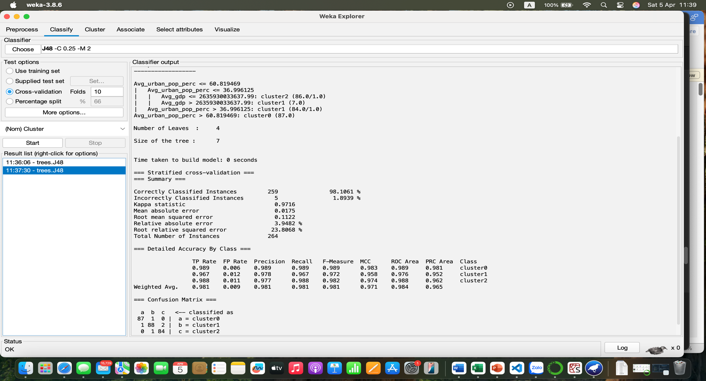

Figure 2: Decision tree classifier results

Figure 2 says that the performance metrics are highly accurate with 259 correctly classified instances out of 264, low error rate which is only 1.89%, strong Kappa statistic which is 0.97, MAE: 0.017, RMSE: 0.1122.

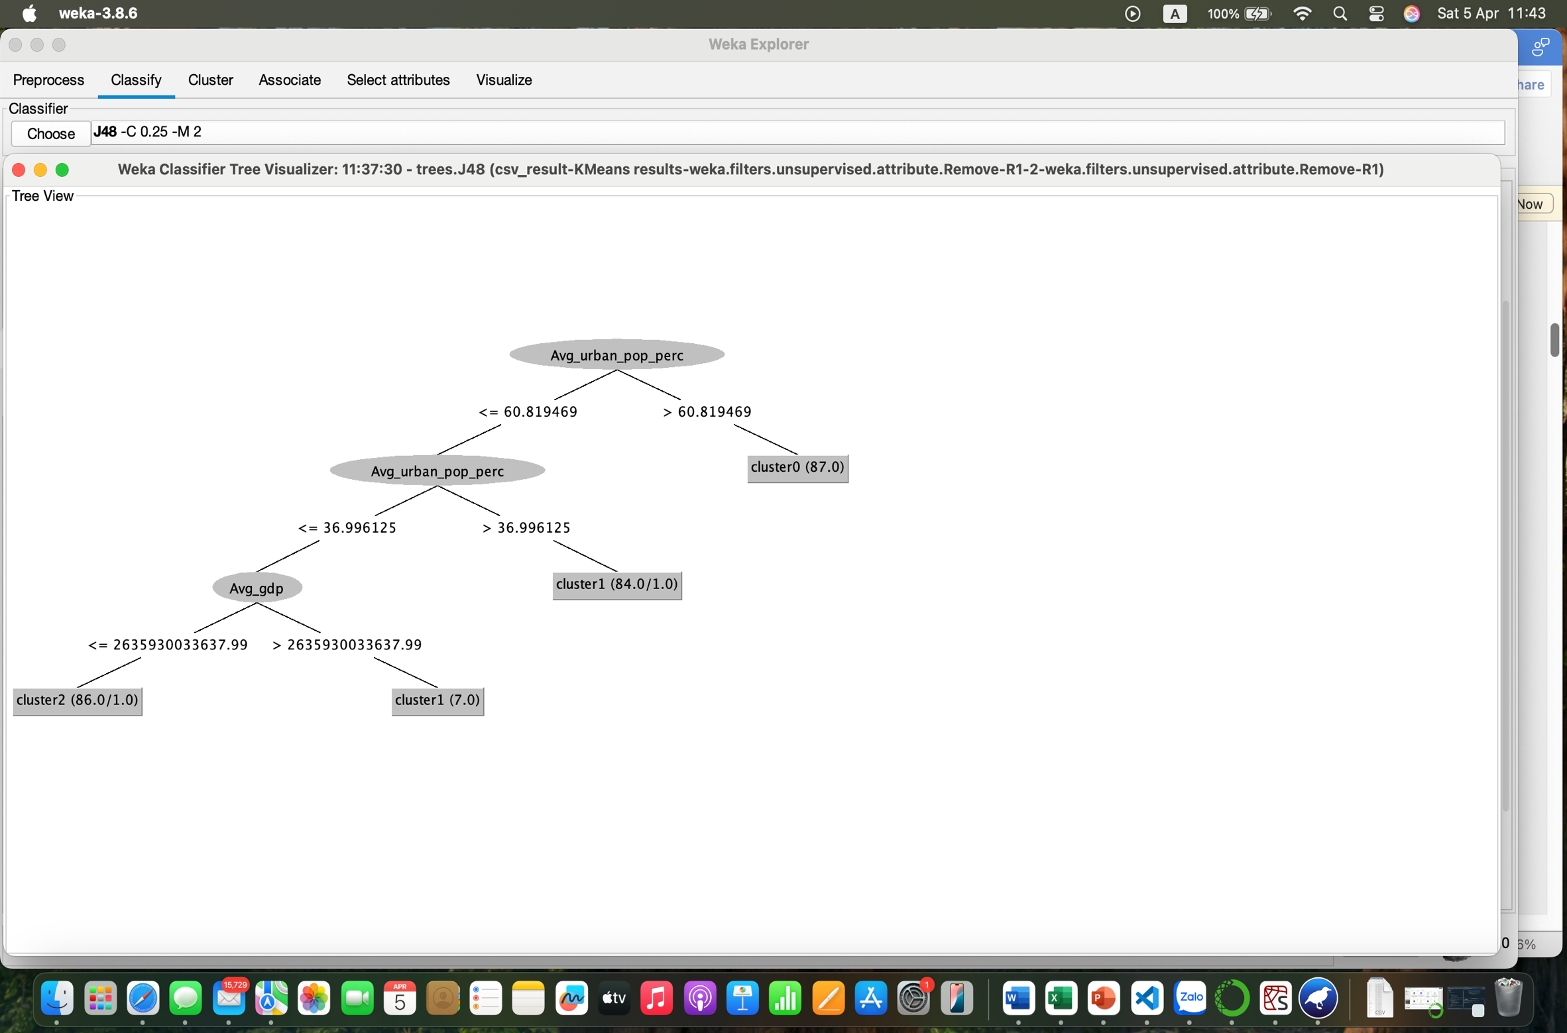

Figure 3: Decision tree visualization

It is apparent that cluster 0 is assigned with the importance score that is Avg_urban_pop_perc when Avg_urban_pop_perc is greater than 60.81. Meanwhile, cluster 1 and cluster 2 are determined by Avg_GDP indicator.

Here are top 10 countries in each cluster based on their most important scores.



Figure 4: Top 10 countries in cluster 0



Figure 5: Top 10 countries in Cluster 1



Figure 6: Top 10 countries in Cluster 2

Figure 4 reveals the fact that there is a disparity in total population and GDP among countries in cluster 0 because these top countries have small population and low GDP despite very high urbanization. Hence, countries in cluster 1 and top countries in cluster 2 seem to be the most attractive markets when considering their combination of size and economic strength.

Specifically, cluster 1 includes low and middle-income groups (Figure 7).



Figure 7: Income groups in Cluster 1

Here are regions included in cluster 1:



Figure 8: Regions in Cluster 1

These regions are then visualized with the tree map with a view to highlighting the most potential regions.

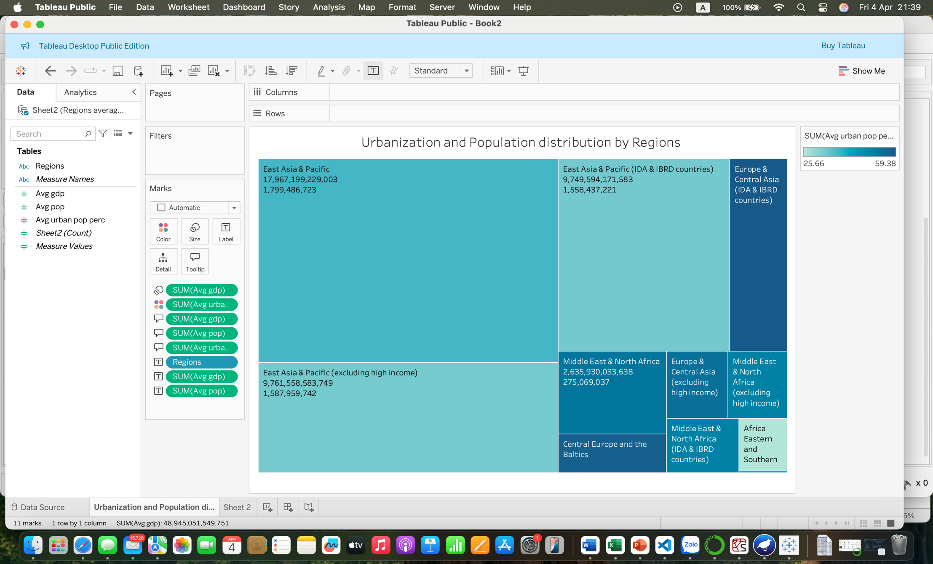

Figure 9: Distribution of total population, GDP and urbanization by regions in Cluster 1

Figure 9 provides insights of the regions as below:

* East Asia & Pacific has biggest boxes meaning highest GDP and population. However, this area has a moderate urbanization rate.
* Middle East & North Africa has much lower GDP and population but higher urbanization.
* Europe & Central Asia is varied based on economic classifications with different urbanization rates.
* Africa Eastern and Southern has a very small box showing both low GDP, population and low urbanization rate (lightest color)

## ***Analysis using Compound Annual Growth Rate***

To identify long-term fast-growing markets for the multinational company, the Compound Annual Growth Rate (CAGR) was also utilized to analyze total population growth trends, urbanization growth and GDP growth over the years from 1960 to 2003. CAGR shows a value’s growth rate per year over multiple years with assumption of a steady growth to reflect the overall trend (Jake, 2025).

In this analysis, CAGR makes it easy to compare growth trends between different countries and indicate future values which helps to uncover opportunities of expansion for the company. The key indicators in the analysis of fast-growing markets include Population CAGR, Urbanization CAGR and GDP CAGR. They are calculated on Excel using below formulas:

$$Population CAGR={\left(\frac{{Population}_{2023}}{{Population}_{1960}}\right)}^{\frac{1}{2023-1960} }-1$$

$$Urbanization CAGR={\left(\frac{{Urbanization}_{2023}}{{Urbanization}_{1960}}\right)}^{\frac{1}{2023-1960} }-1$$

$$GDP CAGR={\left(\frac{{GDP}_{2023}}{{GDP}_{2000}}\right)}^{\frac{1}{2023-2000} }-1$$

In the formula of GDP Compound Annual Growth Rate, due to the missing data in the early stages, the formula will be used to calculate GDP growth rate between 2000 and 2023.

### *Population growth analysis and insights*

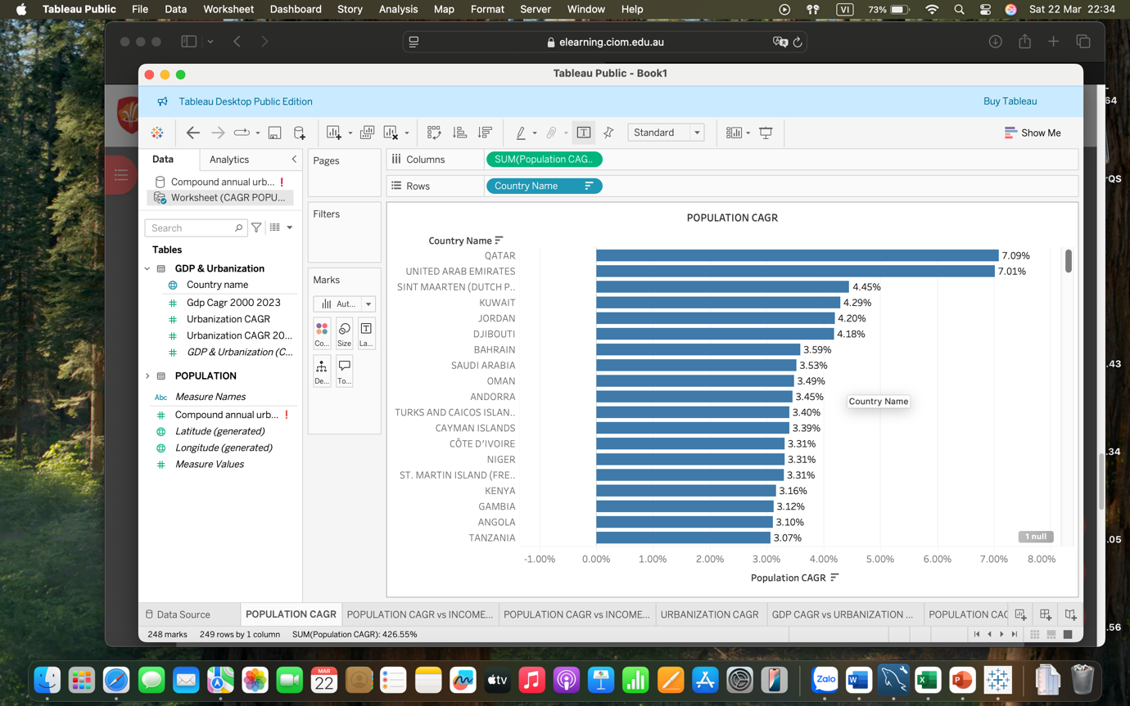

Figure 10: Countries with top CAGR in Population

Figure 10 presents countries with top high CAGR in population meaning that these countries’ population grows rapidly over the period from 1960 to 2023, which is meaningful to certain extents of economic and business. It can be seen that most of the top 10 fastest-growing population countries are in Middle East & North Africa region such as Qatar, UAE, Kuwait, Jordan, Bahrain, Saudi Arabia, Oman and Djibouti. The insight is that these countries are potential markets with a large customer base because a growing population brings a high demand for various sectors of retail & consumer goods and services, housing and construction, healthcare and education. These countries also offer a large young labor market and infrastructure development with a high purchasing power (Danan, 2021).

### *Urbanization growth analysis and insights*

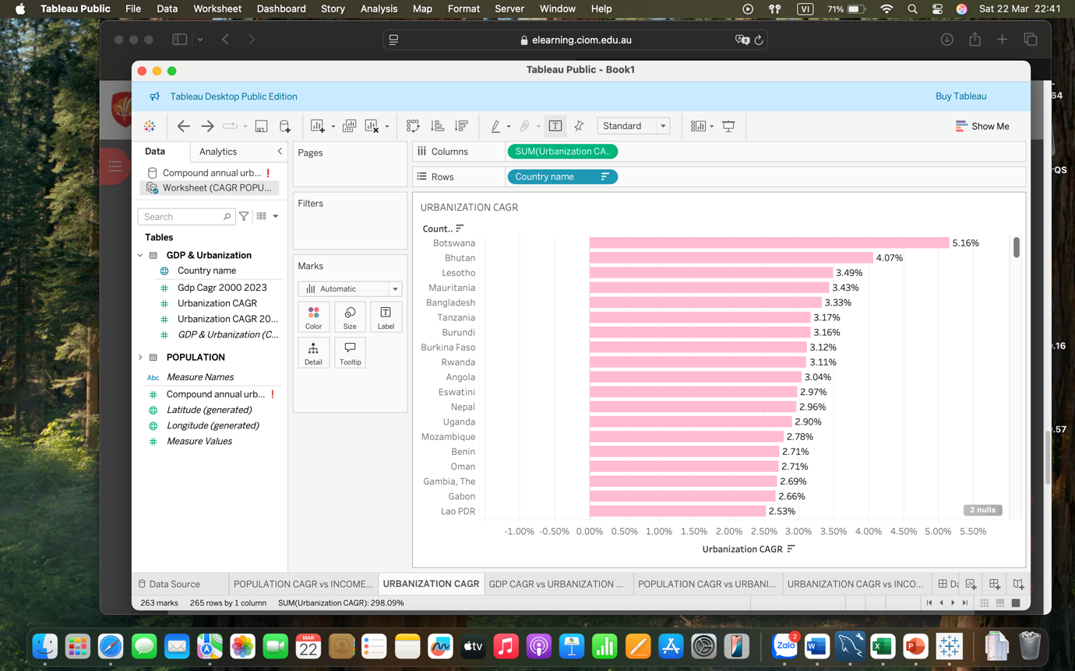

Figure 11: Countries with top CAGR in Urbanization

Another key to identify fast-growing markets is increasing urbanization rates as urban areas make a large contribution to consumer market and general economic growth (Shangze et al., 2021). Figure 11 exhibits the trend that more people moving to urban areas reflects several business implications such as an expanding demand for housing, infrastructure, transportation, construction in big cities and urban areas. Businesses also can take opportunities in service industries of technology, finance, healthcare and entertainment.

### *GDP vs urbanization growth based on income groups analysis and insights*

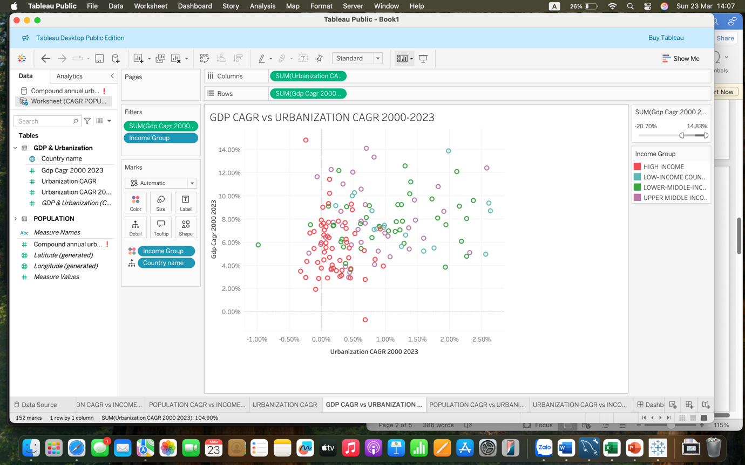

Figure 12: CAGR of GDP and Urbanization by Income groups

From the scatter plots chart, it can be seen that most of the countries having both high urbanization and economic growth rates are middle-income countries including China, Vietnam, Cambodia, Angola, Kenya, Poland, Ireland, South Africa, Turkey, India, Bangladesh, Indonesia. These countries span across East Asia and Pacific, South Asia, Europe Central and Sub-Saharan Africa which are fast-growing markets for the best potential business expansion. With rapid economic growth, demographic movement and urbanization growth, these countries bring potential opportunities for businesses to enter the markets.

On the other hand, the high-income countries with a stable or slow economic and urbanization growth such as the UK, Italy, Austria, Canada, Aruba, Curacao, Spain, Norway, Belgium, Switzerland are not favorable destinations for expansion for some reasons. Firstly, their already-near-maximum urbanization do not create new consuming behaviors that limits opportunities for businesses. Secondly, their low or even negative population growth rates reflect their aging population which is not a favorable factor for new businesses seeking for potential labor markets. Lastly, their mature economic with high competition makes it hard for new businesses to enter. It is apparent that fast-growing markets are the ones combine both of these three factors well.

## ***Analysis’s results***

Analysis in the second approach enhances the insights from the first approach that should-be-selected countries are middle-income countries. They are potential and fast-growing markets identified from cluster 1 and top countries with highest GDP in cluster 2. They are specifically allocated in regions as below:

* Asia: China, Turkey, Iran, Malaysia, Philippines, India, Pakistan, Bangladesh, Indonesia, Thailand, Viet Nam
* Europe: Poland, Ireland, Portugal
* Africa: South Africa, Egypt, Nigeria.

These countries have common characteristics such as young population with high population CAGR, rapid economic growth, industrialization and urbanization. The businesses trying to find rapid expansion can take opportunities in multiple sectors such as technology, goods and services, e-commerce, retails, housing, transportation and so on in these countries.

# **Overlay analysis**

## ***A comparative analysis of global urbanization and population trends***

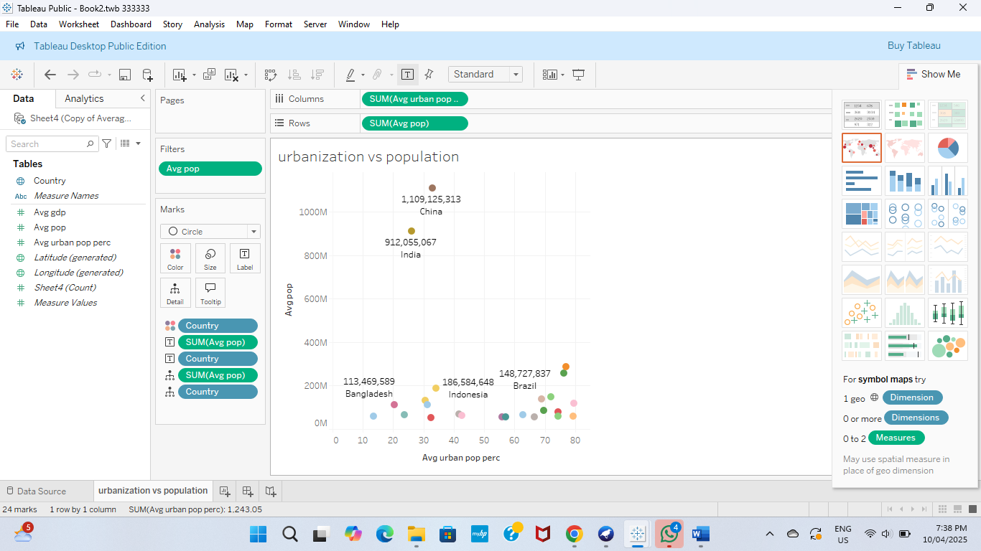The analysis uses average population and average urban population percentage data across multiple countries was analysed and came up with a data with average population percentage and average urbanization. A scatter plot was generated, with X-axis: Average Urban Population Percentage (urbanization level) and Y-axis: Average Total Population (population size) in Tableau.

Figure 13: Distribution of countries based on Average Population and Urbanization percentage

Figure 13 shows that only countries with an average population greater than> 50 million were included to maintain focus on large, potentially lucrative markets.

* High Population & High Urbanization

Countries in the top-right quadrant of the scatter plot combine both high total population and high urbanization levels. These are ideal for multinational expansion due to a large consumer base, improved infrastructure and access, greater potential for technology, services, and logistics implementation. These countries are: China, Brazil, Russia, Mexico, Philippines, Iran.

* High Population & Low Urbanization

Strong long-term potential. These countries have large populations but are still urbanizing, making them ideal for future investment India, Pakistan, Bangladesh, Ethiopia, Nigeria.

* Low Population & High Urbanization:

Smaller countries but with strong infrastructure and urban concentration. These are ideal for targeted or niche expansion: Chile, Portugal, Greece, Serbia, Czech Republic.

* Low Population & Low Urbanization:

Limited short-term potential due to low population and lower urban infrastructure such as Namibia, Armenia, Laos, Lesotho, Bhutan.

## ***Top Candidates for Expansion***

* Brazil stands out as a primary candidate, with an average population of approximately 148 million and an urban population percentage of 76%. This country is highly urbanized and strong economically, this country provides strong opportunities for expansion in retail, logistics, and consumer services.
* Mexico has a mean population of 94 million and an urbanization rate of 74%, it offers growing urban population. Its proximity to the United States and favourable trade deals makes it attractive for manufacturing, logistics, and technology operations.
* The Philippines has about 64 million people and 55% urbanization, is experiencing rapid urban growth and has a digitally linked youth demographic. This environment is favourable for the growth of business process outsourcing, financial technology, and e-commerce services.
* Iran has a population of about 61 million and 66% urbanization. This country has a growing urban middle class and increasing demand in sectors such as healthcare, education, and technology. However, expansion into Iran should consider geopolitical factors and potential risks.

## ***Emerging Urban Growth Markets***

These countries have large populations but lower urbanization levels. However, they are rapidly urbanizing and present significant long-term opportunities.

* India, with a massive population of around 912 million and an urbanization rate of 32%, is undergoing rapid development in urban regions. There are strategic opportunities in infrastructure development, the digital economy, and healthcare services.
* Pakistan, with approximately 130 million people and 35% urbanization, is experiencing high population growth and increasing urban migration. It is a strong candidate for investment in telecommunications, retail, and urban transport systems.
* Bangladesh, home to about 108 million people and with an urbanization rate of 23%, is still predominantly rural but rapidly urbanizing. This creates opportunities in low-cost manufacturing and mobile-based digital services.

## ***Analysis’s results***

For strategic expansions, short-term expansion targets and high readiness Brazil, Mexico. For long-term strategic investment the countries that are high potential are India, Philippines, Pakistan, Iran, Bangladesh. This analyses the operations in currently urbanized nations while positioning for future dominance in rapidly urbanizing economies.

# **Assessment on Sustainability**

## ***Things to consider***

The dataset spans from 1960 to 2023. The clustering results show historical trends in sustainability and development patterns over six decades. Our conclusion would be overall trend in urbanization, energy consumption, and emissions of selected countries from previous analysis.

* Asia: China, Turkey, Iran, Malaysia, Philippines, India, Pakistan, Bangladesh, Indonesia, Thailand, Viet Nam
* Europe: Poland, Ireland, Portugal
* Africa: South Africa, Egypt, Nigeria.

## ***Cluster analysis***

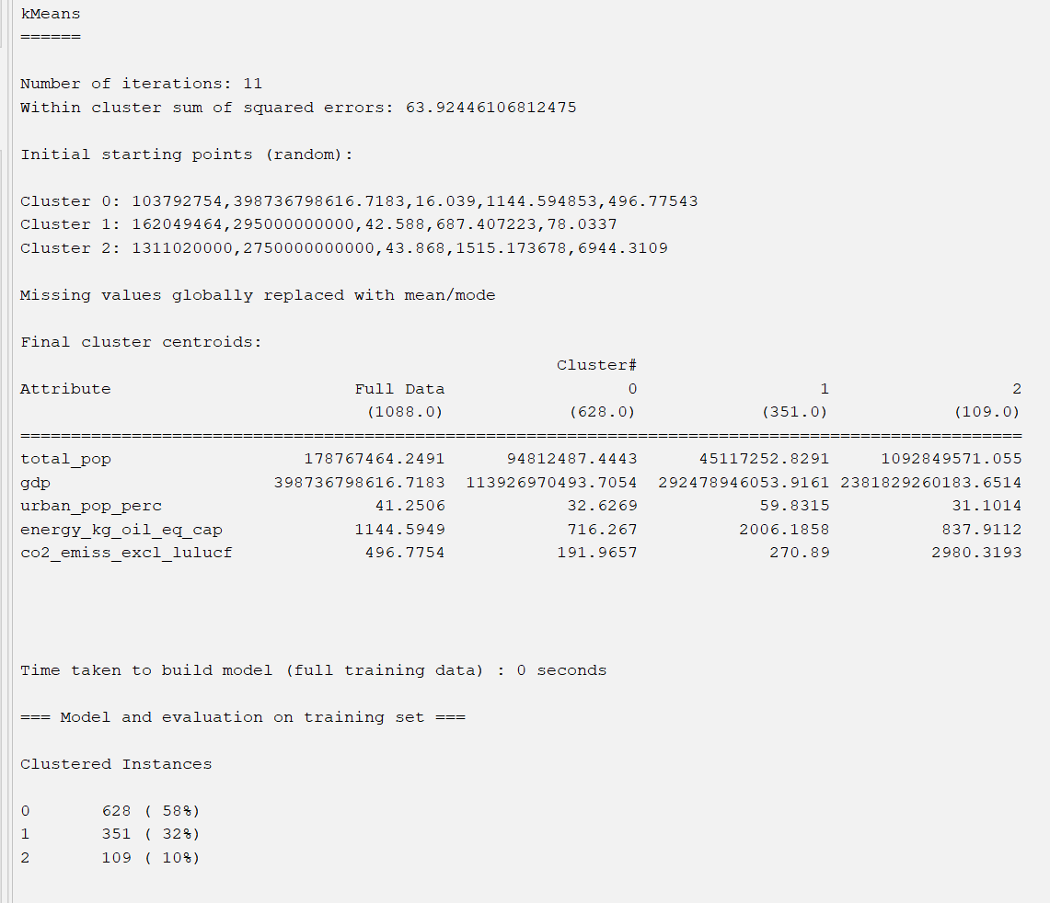

Figure 14: k-Means clustering results based on CO2 emissions and energy consumption

Our data has 16960 instances, and it is divided into 3 clusters based on 7 attributes (ignored the country and a year).

|  |  |  |  |  |
| --- | --- | --- | --- | --- |
| **Cluster** | **Urban Population** | **Energy Consumption per Capita (kg oil eq.)** | **CO2 Emissions (metric tons)** | **GDP (approx.)** |
| **0** | Mid (32.6%) | Low (716.3) | Lowest (192.0) | Low (113.9B) |
| **1** | High (59.8%) | Very High (2006.2) | Moderate (270.9) | Mid (292.5B) |
| **2** | Low (31.1%) | Moderate (837.9) | Highest (2980.3) | Very High (2.38T) |

* Cluster 0 (Mid Urbanization, Low CO₂): Low urban population (31.6%), moderate Energy consumption per capita (app. 716.3), lowest CO2 emissions (192.0).
* Cluster 1 (High Urbanization, High Energy, Moderate CO₂): Highest urban population (59.8%)), very high Energy consumption per capita (2006.2), lower CO2 emissions (270.9).
* Cluster 2 (Low Urbanization, Highest CO₂): Low urban population (31.1%), Moderate Energy consumption per capita (837.9), but highest CO2 emissions (2980.3).
* Sustainability conclusion

## ***Cluster insights***

### *Insight 1*

* Mid urbanized countries have lower energy demands and emissions.
* High urbanized countries have high energy consumption and moderate emissions.
* Low urbanized countries have moderate energy consumption and highest emissions.

### *Insight 2*

* The most urbanized (Cluster 1) has moderate CO₂ than low urbanized countries. Which can be analysed as urbanization can be sustainable with clean energy.
* Cluster 2 emits more CO₂ despite using moderate energy.

## ***Sustainability analysis’s results***

As wrote down in our population growth rate analysis, the following 17 countries meet our initial requirement. To further narrow our options, we now need to select sustainable countries by considering their CO2 emissions from 1970-2020. Based on the Weka cluster visualization, the countries grouped by low, medium, and high CO₂ emissions.

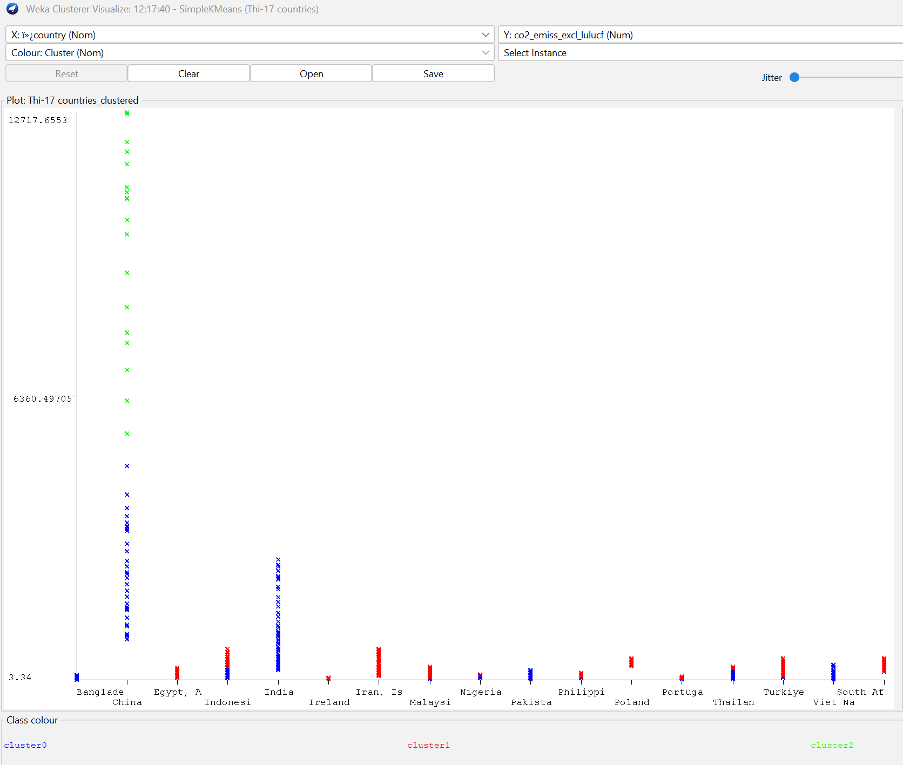

Figure 15: CO2 emission levels of suggested countries

|  |  |  |  |
| --- | --- | --- | --- |
| **Cluster** | **CO₂ Emissions (Metric Tons)** | **Countries** | **Characteristics** |
| **Cluster 0**  **Low** | < 500 | **Viet Nam, Philippines, Pakistan, Portugal, Ireland, South Africa** | Smaller economies, lower industrialization. |
| **Cluster 1**  **Medium** | 500–3,000 | **India, Indonesia, Malaysia, Thailand, Turkey, Egypt, Poland, Spain** | Rapidly industrializing, mid-sized economies. |
| Cluster 2  High | > 3,000 | **China** (12,717.7), **Iran** (6,360.5) | Major industrial powers, heavy reliance on fossil fuels. |

|  |  |  |  |
| --- | --- | --- | --- |
| **Cluster** | **CO₂ Trend (Over Years)** | **Countries** | **Political aspect** |
| **Cluster 0**  **Low** | **Stable/Declining** | Vietnam, Portugal, Ireland | Renewable energy adoption (e.g., EU policies in Portugal/Ireland). |
| **Cluster 1**  **Medium** | **Gradual Increase** | India, Indonesia, Turkey, Poland | Industrial growth + urbanization (e.g., India’s coal reliance). |
| Cluster 2  High | **Sharp Rise** | China, Iran | Fossil fuel expansion (e.g., China’s coal plants post-2020). |

# **Recommendations**

The first analysis suggested multiple countries in different regions as potential and fast-growing markets. The second analysis revealed the same outcomes with the selected countries in Asia region, except for Brazil and Mexico which are in Latin America & Caribbean. Despite good indicators of population and economic growth with high urbanization percentage, these countries are still labelled as emerging economies due to inequality, infrastructure gaps (Amendolara, 2020). After conducting a further consideration on these countries, the team decided to add them into the list of suggestions for the company. The third analysis is another evaluation to strengthen the first and second analysis’s results. It highlighted two largest CO2 emitters that are China and Iran. However, China is also the biggest investor in renewable energy with a strong green transition investment of solar panels, EVs and batteries (IEA, 2024). Iran is still depending heavily on fossil fuel and their renewable projects are not really attractive (Worldometer, 2022). As a result, the team made the final decision of the selected countries by resgions as below:

* Asia: China, Turkey, Malaysia, Philippines, India, Pakistan, Bangladesh, Indonesia, Thailand, Viet Nam
* Europe: Poland, Ireland, Portugal
* Africa: South Africa, Egypt, Nigeria.
* Latin America & Caribbean: Brazil, Mexico

# **Conclusion**

The report analyses two real-world datasets to identify countries with high potential and consistent growth as new markets for the multinational company. Key features such as population growth, urbanization rates, income groups and sustainability were assessed to highlight these markets. They are countries not only experiencing rapid population and urbanization growth but also showing significant economic development and manageable environmental challenges. The analysis provides a data-driven foundation for strategic decision making to make sure long-term development of the company.

**Reference:**

Amendolara, M. (2020). *Inequality on the rise: A study of inequality in Mexico and Brazil.* Global Majority E-Journal, 13(1), 4–19. https://www.american.edu/cas/economics/ejournal/upload/global_majority_e_journal_13_1_amendolara.pdf​

Danan, G. (2021). Major Trends in Population Growth Around the World. https://pmc.ncbi.nlm.nih.gov/articles/PMC8393076/

International Energy Agency. (2024). *World energy investment 2024 – China.* <https://www.iea.org/reports/world-energy-investment-2024/china>

International Energy Agency. (2024). Energy technology perspectives 2024. https://www.iea.org/reports/energy-technology-perspectives-2024

Shangze, D., Fei, F., Zhang, K., Haiqian, K. (2021). *Innovation agglomeration and urban hierarchy: evidence from Chinese cities*. <https://doi.org/10.1080/00036846.2021.1937507>

Worldometer. (2022). *Iran CO₂ emissions.* <https://www.worldometers.info/co2-emissions/iran>

OpenAI. (2025). ChatGPT (April 2025 version) [Large language model]. https://chat.openai.com/ co2-emissions/